SEM5000
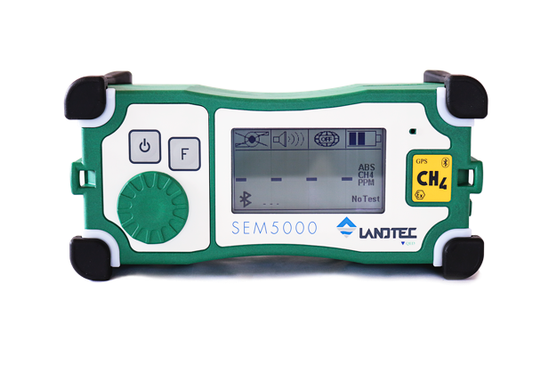
Surface Emissions Monitor
OPERATING MANUAL
QED Environmental Systems, Inc.
2355 Bishop Circle West
Dexter, MI. 48130

Table of Contents
ATEX WARNINGS 4
General Description 5
User Interface 6
Overview 6
Connections 7
Display 7
Navigation 8
Using the SEM5000 9
Turning the instrument ON 9
Turning the instrument OFF 10
Using GPS 10
GPS Activation 10
SEM5000 Set Up 11
Field Calibration 13
Air Test 1 14
Gas Test 1 15
Air Test 2 16
Gas Test 2 17
Air Test 3 18
Gas Test 3 18
Up Wind Test 19
Down Wind Test 20
Functions 21
Data Save Options 21
Delete Memory 22
Concentration Measurement 22
Alarms 22
Backlight and Contrast 23
Bluetooth 23
Maintenance 24
Changing the Battery 24
Charging the Battery 25
Replacing the Water Trap Filter 27
Extendable Sample Probe Maintenance 28
Replacing the Dust Filters 28
Replacing the Sample Tubing 30
Factory Calibration 33
Instrument Specifications 34
Trouble Shooting 36
Pump Error 37
Restarting the Pump 37
Replacement Parts 38
SEM5000 Warranty 39
Appendix A – Safe Use of the Instrument 40
Laser Radiation 40
Other Precautions for Usage 40
Testing and Maintenance 40
Repair 40
Appendix B – Bluetooth Module Compliance 41
United States 41
Canada 41
Europe 42
Appendix C – EU Declaration of Conformity 43

ATEX WARNINGS
Read the entire SEM5000 User Manual prior to operating the instrument
This warning is issued to ensure proper knowledge of the instrument’s operation.
Replacment of the battery must only be performed in non-hazardous areas
Do not charge the battery in hazardous areas
The charging of the batteries must be performed only in a safe place with the appropriate external adapter QED SEM-BC.
Do not open the instrument
Only authorized personnel can open the instrument for maintenance and repair.
The opening of the instrument by unauthorized personnel will void the product warranty.
Maximum voltage Um < 15V
The maximum voltage that can be applied to the non-intrinsically safe connection facilities of associated apparatus (battery charger) without invalidating the type of protection is 15 volts.
Antistatic Personal Protection Equipment
The operator shall be equipped with a complete antistatic Personal Protection Equipment (PPE), in combination with conductive or dissipative ground, and shoes with a resistance below 10⁸Ω.
Do not connect the SEM5000 instrument, SEM5000 battery or SEM5000 battery charger to other equipment
These devices are only designed to be used together in order to work properly and guarantee the safety of the users.
Atex accessories
Use only the following accessories with the instrument SEM5000:

Rechargeable battery pack lithium ion (PBLO.NNNN.YY 3,7V 4000mAh)
Code: 205014
Battery charger (CCLO.NNNNN.YY)
Code: 100189
Power supply (Um<15 volts)
Code: 423007

General description
The SEM5000 is a digital gas detection instrument from QED Environmental Systems, Inc. The intended use of the SEM5000 is the measurement of low concentrations of methane in the field (Landfill surface emissions monitoring, leakage surveys of natural gas networks, control pinpointing outside buildings, quantifying methane fluxes, and laboratory applications for gas analysis).
The instrument is selective exclusively to methane, thanks to the patented Laser technology inside. The SEM5000 delivers reliable and accurate measurement of methane concentrations, even if the sample contains other gases or hydrocarbons. Due to its lightweight design and modest size, the SEM5000 can be easily transported and is ideal for measuring methane concentrations in the field, (landfills, site investigations or gas networks). Thanks to its metrological sensitivity, accuracy, stability and response time, the SEM5000 is the perfect instrument for the detection and quantification of methane emissions.
The single-dial function selector makes the SEM5000 easy to use and the large, back-lit LCD-display provides easy to read menus and results. The SEM5000 has a measuring range covering 0 to 1,000,000 PPM (part per million) or 100% methane concentration. The SEM5000 also offers a rapid response time, improving the efficiency and saving time. The exceptional reactivity of the SEM5000 laser technology provides excellent results during field scans for fugitive traces of methane. The noteworthy combination of high sensitivity and rapid response deliver outstanding measurement quality. The SEM5000 is provided with integral GPS and Bluetooth, eliminating the need for additional devices. The internal memory is capable of storing up to 48 hours of scan data.
The SEM5000 is the perfect, easy-to-use instrument for accurately measuring and recording methane concentrations during surface emissions monitoring.

The SEM 5000 exists in Atex version and has been certified with the intrinsic safety protection mode and has obtained the following marking:
II 2 G Ex ib op is IIB T3 Gb -25°C<Ta<+50°C

In hazardous environment the user must take care of the following standards EN 1127-1:2011 (Explosive atmospheres- Explosion prevention and protection - Basic concepts and methodology) and CLC/TR 50404:2003 (“Electrostatics Code of practice for the avoidance of hazards due to static electricity”).

ATTENTION: The photos shown in this user manual are indicative.

user interface

Overview
A
B
C
D
E
F

 | Description
[A] | ON/OFF button + Backlight
[B] | Function button
[C] | Buzzer
[D] | Selector Dial
[E] | LED Alarm Lights and Impact Bumpers
[F] | Strap Connectors

Connections
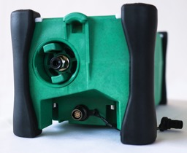
A
B
 | Description
[A] | Gas Sample Inlet and Water Trap Filter Holder
[B] | Battery Charger/Data Download Connector

Display
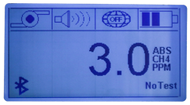
A
B
C
D
E
G
H
I
F

 | DESCRIPTION
[A] | Pump Status/Save Location/GasTest Indicators
[B] | Audible Alarm Status
[C] | GPS Status
[D] | Battery Charge Status
[E] | Bluetooth (when connected to your PC, icon will change to
[F] | Percentage of Memory Used
[G] | Concentration Level of Sample
[H] | Test Status Indicator/Gas Threshold
[I] | Reading Type (ABS)/Gas Measured (CH4)/Scale of Measurement (PPM or %VOL)

Navigation

Push the green selector dial and the menu will appear in the display window.
Use the selector dial to scroll through the available menu options.

Once you have identified your desired option, push the selector dial to confirm your selection.

While the Option menu is active, the concentration value of the gas sample is shown in the upper right-hand corner of the display. The exceedance threshold is displayed in the lower right-hand corner of the display.

Select “ESC” to exit the Options menu.

Start Test – Begin pre- scan span gas test
Stop Test – Complete pre-scan span gas test
Select Gas 500/200/100 – Choose PPM value of exceedance threshold
ON/OFF Pump – Start and stop pump
ON/OFF Buzzer – Enable and disable audible exceedance alarm
ON/OFF GPS – Enable and disable GPS
ON/OFF Log – Start and stop auto save for scan data
Sel. Save Interval – Select auto save interval, (1 second to 10 seconds)
Save Event – Manually save an additional event during auto save
Delete Memory – Clear all saved data
LCD Contrast – Adjust display contrast
Manual Save – Manually save readings during scan, (disables auto save)
ESC – Exit Option menu

using the sem5000

Turning the instrument ON

Press and hold the ON/OFF button for few seconds, until the display is activated.
The start-up sequence includes several steps:

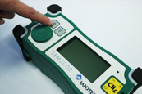

The Landtec Logo is displayed

Information about the version of the instrument firmware, serial number of the instrument, next recommended calibration date is displayed

NOTE: If there is existing data stored in the instrument’s memory from a previous survey, the message “DATA TO DOWNLOAD” will appear at the bottom of the screen.
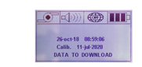
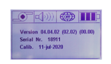

The instrument will warm up. The warm up lasts approximately 20-30 seconds.

NOTE: The instrument’s functions are not available during the warm up period.

Once the warm up and calibration are complete, the four LED lights will blink and the alarm will sound

A concentration level will be displayed. This is the actual measurement of methane in the atmosphere. Naturally occurring methane levels in atmosphere are typically 2.5ppm

The SEM5000 is now ready to operate

Press the Function button to turn off the pump.

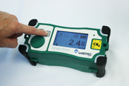

An “X” will appear over the pump icon in the upper left corner to indicate that the pump is off.

Turning the instrument OFF

To switch off the instrument, press and hold the ON/OFF button [A] for a few seconds.
A shut off message will appear on the display and will count down to shut off.

Using GPS

Upon start up, the GPS is not active. It must be activated prior to field calibration.

NOTE: Data is only acquired and saved when the GPS is active

GPS Activation
- Push the Selector dial to display the Option menu
- Use the Selector dial to scroll through options to ”ON/OFF GPS”
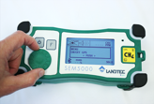
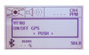
- Push the Selector dial to turn on the GPS

- Press the selector dial to confirm the selection. An “X” will appear over the GPS globe icon at the top of the screen while it attempts to acquire a signal
- Once the signal has been acquired, the “X” over the GPS icon will be replaced by the letters “GPS” with alternating blue and white dots at the corners of the icon
NOTE: GPS must be activated in order for the instrument to save any scan data
Icon | Description | Icon | Description
 | GPS active but waiting for signal |  | GPS off
 | GPS active |  | Save location

NOTE: The GPS module is a high-performance receiver with the ability to track up to 20 satellites.
Start up time for the GPS module can vary according to the strength of the actual signal received.
The presence of high trees or buildings, aerial power lines or other obstructions will affect the signal. Typically, in an open area, the GPS will fix in 1 to 3 minutes.
In the event of signal loss during the survey, the instrument will continue to log gas values and will associate the to the last saved tracked GPS position until the signal is reacquired.

SEM5000 Set Up

Once GPS has been activated, survey parameters will need to be set up. Gas Exceedance levels and data storage preferences must be selected.
- Push the Selector dial to display the Option menu and scroll to the “Select Gas 500/250/100” option and press the Selector dial to display the gas concentration menu
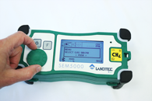
- Scroll to choose 500, 250 or 100 parts per million and push the Selector dial to store your choice

- Push the Selector dial and scroll to the “Log” option
- Press the selector dial again to choose “ON” or “OFF”

NOTE: Once logging has been turned “ON” or “OFF” it will remain in that mode until changed by the user.
The “Log” function must be turned “ON” in order for the SEM5000 to automatically save survey readings.
When the “Log” function is not activated, the word “OFF” will appear at the bottom of the display screen.
When the “Log” function is activated, the percent symbol, (%), will be displayed at the bottom of the screen. During the survey, this will indicate the percentage of available memory that has been used.
- Press the Selector dial and scroll to the “Select Save Interval” option and push the Selector dial to display time save options
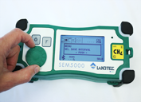
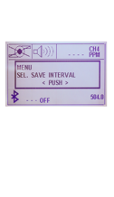

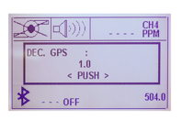
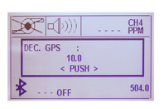
- Scroll to select auto save time, (1 second to 10 seconds), and press again to confirm your selection

NOTE: If you do not wish to utilize the Auto Save function, bypass the “Select Save Interval” option and instead activate the “Manual Save” option.
This option will allow you to use the “Function” button to manually save readings at desired intervals.
- The instrument is now ready for field calibration

Field Calibration

Field calibration consists of three alternating measurements between two calibration gases, (zero air and methane)
- Connect demand-flow gas regulator(s) to calibration gas bottles
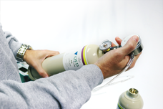
NOTE: The regulator flow must be a minimum of 0.6L/min to avoid restricting the pump.
The SEM5000 package is provided with one demand-flow regulator with a C10 fitting. It is recommended that two regulators be used, (one per bottle), for ease of calibration.
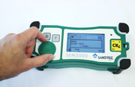
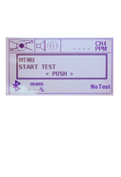
- Push the Selector Dial, scroll to the “Start Test” option and press the Selector dial again

- The instrument will guide you through the field calibration procedure with alternating icons appearing in the upper left corner of the screen to indicate
  - Air
  - Gas250/500
  - Upwind Test
  - Downwind Test
- The screen will also display instructions to start, stop and track each test

- Once you have selected “Start Test”, the screen will display the instructions, “Press F to start Air 1”

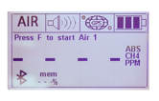

Air Test 1

- Connect the tubing from the gas regulator for the zero air calibration gas to the sample inlet of the SEM5000
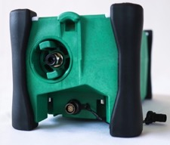
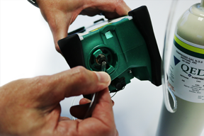

NOTE: If the tube is not fully inserted into the sample inlet of the SEM5000, the concentration readings during field calibration may appear to be erratic and difficult to stabilize.
- Press the Function, (F) button
- The pump will start and the display will begin to count down as the zero air is drawn into the SEM5000

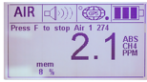
- Once the reading has stabilized on the display, press the Function, (F) button again to stop the pump and complete Air Test 1
- Stabilization will take approximately 20-30 seconds

- Once you stop the pump to complete Air Test 1, the screen will display the instructions, “Press F to start Gas 1”
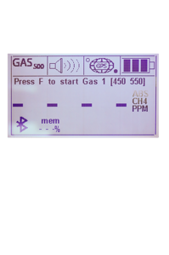

Gas Test 1

- Disconnect the zero air tube from the sample inlet of the SEM5000 and connect the tubing from the gas regulator to the methane calibration gas to the sample inlet of the SEM5000
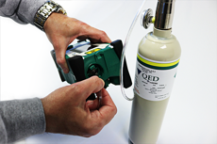

- Press the Function, (F) button
- The sample concentration display will count up to the highest reading as it samples the bottled gas
- The gas test is timed and will continue for twenty seconds. The remaining time is displayed above the sample concentration level
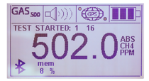

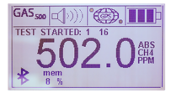
- Once the 20 second test time is complete, the message “TEST OK SAVED” will appear on screen.
- When “TEST OK SAVED” appears, remove the tube from the sample inlet of the SEM5000
  - The pump will continue to run for several seconds to clear any residual methane from the chamber before the next test begins.
- After purging for several seconds, the pump will shut off automatically

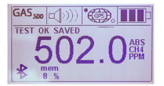
- After the pump shuts off, the instructions “Press F to start Air 2” will appear

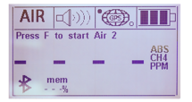

Air Test 2

- Connect the tubing from the gas regulator for the zero air calibration gas to the sample inlet of the SEM5000
- Press the Function, (F) button
- The pump will start and the display will begin to count down as the zero air is drawn into the SEM5000
- Once the reading has stabilized on the display, (this will take approximately 30 seconds), press the Function button again to stop the pump and complete Air Test 2

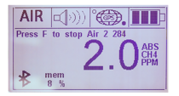
- Once you stop the pump to complete Air Test 2, the screen will display the instructions, “Press F to start Gas 2”
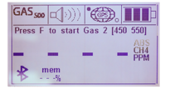

Gas Test 2

- Disconnect the zero air tube from the sample inlet of the SEM5000 and connect the tubing from the gas regulator to the methane calibration gas to the sample inlet of the SEM5000
- Press the Function, (F) button
- The sample concentration display will count up to the highest reading as it samples the bottled gas
- The gas test is timed and will continue for twenty seconds. The remaining time is displayed above the sample concentration level

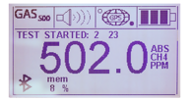
- Once the 20 second test time is complete, the message “TEST OK SAVED” will appear on screen.
- When “TEST OK SAVED” appears, remove the tube from the sample inlet of the SEM5000
  - The pump will continue to run for several seconds to clear any residual methane from the chamber before the next test begins.
- After purging for several seconds, the pump will shut off automatically

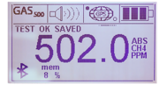
- After the pump shuts off, the instructions, “Press F to start Air 3” will appear
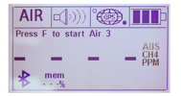

Air Test 3

- Connect the tubing from the gas regulator for the zero air calibration gas to the sample inlet of the SEM5000
- Press the Function, (F) button
- The pump will start and the display will begin to count down as the zero air is drawn into the SEM5000

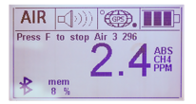
- Once the reading has stabilized on the display, (this will take approximately 20 to 30 seconds), press the Function button again to stop the pump and complete Air Test 3
- Once you stop the pump to complete Air Test 3, the screen will display the instructions, “Press F to start Gas 3”

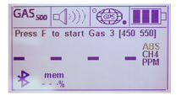

Gas Test 3

- Disconnect the zero air tube from the sample inlet of the SEM5000 and connect the tubing from the gas regulator to the methane calibration gas to the sample inlet of the SEM5000
- Press the Function, (F) button
- The sample concentration display will count up to the highest reading as it samples the bottled gas
- The gas test is timed and will continue for twenty seconds. The remaining time is displayed above the sample concentration level

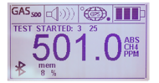
- Once the 20 second test time is complete, the message “TEST OK SAVED” will appear on screen.
- When “TEST OK SAVED” appears, remove the tube from the sample inlet of the SEM5000
  - The pump will continue to run for several seconds to clear any residual methane from the chamber before the next test begins.
- After purging for several seconds, the pump will shut off automatically

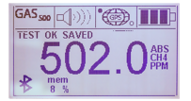
- After the pump shuts off, the screen will display the instructions, “Press F to start Up Wind Test”

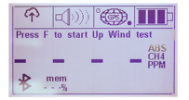

Up Wind Test

- Move to your established “Up Wind” test location and press the Function button, (F) to start the Up Wind test
- The Up Wind test is is a timed test and will draw a sample of atmosphere in through the sample inlet for 30 seconds
- The time remaining in the Up Wind test will be displayed above the sample concentration level

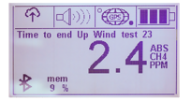
- Once the test is complete, the pump will automatically shut off and the instruction “Press F to start Down Wind test” will be displayed

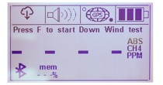

Down Wind Test

- Move to your established “Down Wind” test location and press the Function, (F) button to start the Down Wind test
- The Down Wind test is is a timed test and will draw a sample of atmosphere in through the sample inlet for 30 seconds
- The time remaining in the Down Wind test will be displayed above the sample concentration level

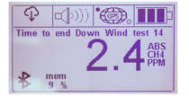
- Once the test is complete, the pump will automatically shut off and the instruction “Press F to start SURVEY” will be displayed

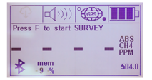
- Field calibration is now complete and the calculated exceedance value is displayed in the lower right corner

NOTE: The exceedance value displayed is the average of the three air/gas test and the Up Wind and Down Wind tests to account for existing background levels. This calculated value will be the alarm threshold for an exceedance and will be stored in the SEM5000 memory for the remainder of the day.
If your SEM event will span multiple days, you will need to perform a new field calibration at the beginning of each day.
If you plan to survey multiple sites on the same day, you will need to perform field calibration at each site.
- Connect the extendable sample probe to the sample inlet of the SEM5000, press the Function button, (F) and begin your survey

Functions

Data Save Options

LOG – Activates the Auto Save function. When “LOG” is enabled, the SEM5000 will automatically save readings as you continue your survey. It will stop saving only if the pump is turned off or when the instrument is shut down.
The SEM5000 is constantly reading the concentration as the sample is drawn in. It in LOG mode, it automatically saves a reading every second, by default. Auto Save intervals can be customized with the Sel.Save Interval option.
Sel. Save Interval – Allows the user to customize the Auto Save intervals. By scrolling with the Selector Dial, the user can choose save intervals of 1 second to 10 seconds.
Manual Save – This option allows the user to save readings manually at desired intervals. When choosing this option, the Auto Save feature is disabled. Using the Selector Dial, the user will scroll through the options menu and use the “ON/OFF Pump” option to start and stop the pump during the survey. Once the pump has started, the user will walk the predetermined scan path. The SEM5000 will be taking samples and displaying concentrations but will not be automatically saving any data. When the user wishes to save a reading, they will press the Function button and that specific reading will be saved. In Manual Save mode, a reading will be saved every time the Function button is pressed.
Save Event – This feature allows the user to save additional points during Auto Save. If there is a point of particular interest that the user wants to note or remember, they will use the Selector Dial to scroll through to the Manual Save option and press the Selector Dial to save that specific location as an event point.

Delete Memory

- To delete the data stored in the instrument, press the Selector Dial and rotate it until the Option menu displays DELETE MEMORY.

- Press the Selector Dial to confirm the selection.
  - A second message will appear to verify that you wish to delete the data.

- If you are certain that you wish to proceed, turn the Selector Dial until YES appears on the screen and press the Selector Dial again.

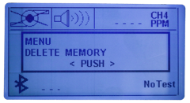
NOTE: The SEM5000 will store up to 480 hours of scan data before the memory must be deleted.

Concentration Measurement

The SEM5000 is able to measure the methane selectively, eliminating potential for cross-gas effects, in a range 0-100% VOL. In the range 0-1000 the scale displayed is PPM. If more than 1%, or 10,000PPM, the displayed scale is %VOL.

The SEM5000 measures in Absolute Mode, providing an accurate reading of the sample and ambient methane concentrations. The measurement reading is shown on the display in Parts Per Million (PPM). Upon start up, the pump will run and measure and display the ambient CH4 concentrations. Normal levels of CH4 in atmosphere are approximately 2.5 PPM.

The SEM5000 is designed to alarm at exceedance levels of 100ppm, 250ppm and 500ppm. The user must establish the desired exceedance threshold level prior to daily field calibration, (see “SEM5000 Set Up”).

Alarms

The SEM5000 features an audible acoustic alarm and flashing LED alarm lights.

The acoustic alarm sounds and the LED flashes, when the instrument is switched ON and when the measured gas has exceeded the alarm threshold.
The acoustic alarm can be enabled or disabled by using the Selector Dial and Options menu.
When the alarm is turned off, the alarm icon appears crossed on the display. When the measured gas concentration exceeds the alarm threshold the LED flashes, even when the acoustic alarm is disabled. As a safety precaution, the LED alarm lights cannot be disabled.

Backlight and Contrast

To change the display illumination, push the “Start” button until you reach the desired illumination. The display has 4 levels of illumination.

To adjust the contrast of the display, press the Selector Dial and scroll through the Options menu until “LCD contrast” appears. Rotate the Selector Dial to increase or decrease the amount of contrast, (from 10% to 100%).
Press the Selector Dial to confirm the selection.

Bluetooth

Bluetooth is always active and the icon appears in the lower, left-hand corner of the display.

Note: For further information please contact Technical Support at QED at (800) 968-2026 or email landtec_support@qedenv.com.

Maintenance

Changing the Battery
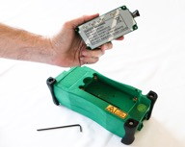
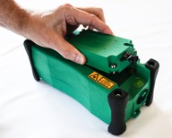
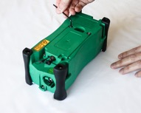
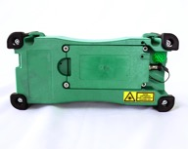
3MM Allen Key
Battery Pack
Remove all four screws
Remove discharged battery
Replace with fully charged battery and tighten screws

Replace the battery only in non-hazardous locations.

Charging the Battery

The SEM5000 is supplied with rechargeable battery pack (PBLO.NNNN.YY 3,7V 4Ah Code 205014). The battery can only be charged using the approved CCLO charger (code 201006) and power supply cord (Code423007), supplied with the unit.

To charge the battery:
- Remove it from the SEM5000, (see “Changing the Battery”)
- Plug the 9-pin connector into the battery’s Battery Charger/Data Download connector

- Plug the power supply cord into the center power port of the charger

- Plug the other end into a standard electrical outlet.
- It is recommended to connect the charger with the power supply according the figure below, using the two polarity connector in conformity with the maximum authorized voltage Um equal to 15V

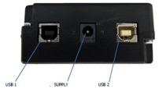

- The charger’s indicator light will glow red when the instrument is charging and will turn green to indicate that the charge is complete

The duration of the complete charge cycle is typically 4 hours 30 min.
The typical autonomy of the device in operation is 10 hours at ambient temperature and with the backlight ON.
Many factors, such as ambient temperature, activation of the backlight or the alarms can affect this duration.

The battery is Lithium ion technology. This battery pack is not restricted according the European and international regulations of dangerous goods. Therefore, the device can be transported by plane following the requirements of the labelling of the package.

The charge level of the battery is shown with a battery icon in the upper, right-hand corner of the screen. It displays three levels of charge. The last level corresponds to the last 30 minutes of operation at 20°C.

Do Not Charge batteries in temperatures below zero degrees C.
Do not charge batteries in hazardous areas
Do not charge battery when connected to SEM5000

NOTE: The SEM5000 battery charger can also be used to connect the instrument directly to your PC for data download if Bluetooth is not available on your computer.
Leave the battery connected to the SEM5000
Plug the 9-pin connector into the battery’s battery charger/download connector

Plug the provided USB cable into the “USB 2” port on the battery charger and connect the other end to your PC

Replacing the Water Trap Filter

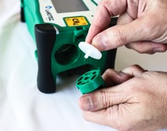
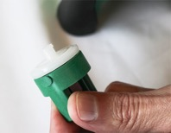
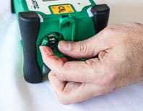
Remove filter holder by turning counter clockwise
Replace water trap filter
Replace filter holder and turn clockwise to lock in place

NOTE: The water trap filter should be checked and changed periodically. It is recommended that it be changed prior to each SEM event. At a minimum, it should be checked quarterly and is recommended to be checked weekly during periods of heavy use.

Extendable Sample Probe Maintenance

Replacing the Dust Filters

The SEM5000 extendable sample probe has two dust filters. The first is a sintered bronze dust filter for course particles and is located inside the windscreen and the end of the wand. The second is a cellulose fiber filter for fine dust particles and is located behind the windscreen.
Both of these filters should be replaced periodically. It is recommended that, at a minimum, they be changed at the beginning of each SEM event. You may need to change them more often, depending on individual site conditions.

To change the bronze dust filter:
Using a 13mm socket, unscrew the bronze dust filter and remove it from its position inside the windscreen
Discard the old filter and replace it with a new filter
Tighten the filter with your fingers and, if necessary, use the 13mm socket for final tighten

To change the cellulose dust filter:
Unscrew and remove windscreen from the end of the sample probe
Once the windscreen has been removed, remove and discard the cellulose filter from the filter holder at the end of the wand
Replace the discarded filter with a new cellulose filter
Replace and hand-tighten the windscreen

Replacing the Sample Tubing

The SEM5000 exdentable sample probe contains a 5-foot section of tubing that directs the sample into the instrument. Should the tube become kinked or break, it must be replaced to avoid restricting the pump or causing errors in the concentration readings.
To replace the tubing:
Unscrew and remove the windscreen from the end of the sample probe
Remove the cellulose dust filter from the end of the filter holder
Unscrew and remove the nut at the top of the filter holder and remove the filter holder from the end of the sample probe
Using a 3mm allen wrench, release the nut inside the filter holder

Remove the old tubing from the quick-connect fitting
Remove the old tubing from the handle end of the sample probe
Feed replacement tubing into the handle end and push it all the way through the probe
Connect the replacement tubing to the quick-connect fitting
Hold the tube, unscrew the filter holder and remove the quick-connect fitting from inside the filter holder

Use the 3mm allen wrench to provide a final tighten
Replace the cellulose dust filter in the end of the filter holder
Replace the filter holder on the end of the sample probe and tighten the nut at the top of the filter holder
Replace and hand-tighten the windscreen
Screw the quick-connect fitting back into the filter holder and hand-tighten

Factory Calibration

It is recommended that your SEM5000 be sent to QED biennially, (every two years), for inspection and calibration.
Your instrument’s recommended calibration due date is shown on the unit’s display screen at start up.

Instrument Specifications
The SEM5000 uses an internal membrane pump. The typical flow is 0.8 l/m. The minimum flow is 0.6 l/m. The maximum flow is 1 l/m.
The use of accessories, such as the probe, can slightly reduce this flow. It is advised to only use the parts and accessories supplied by QED.

The gas sample entrance connector has a size of D2 X D4 mm.

A hydrophobic internal filter protects the device against any entrance of dust or water. It is strongly advised to use an external dust filter in order to avoid the accumulation of dirt in the internal filter.

NOTE: The water trap filter is not designed to protect against chemicals.
The aspiration of water or impurities may cause malfunction of the pneumatic circuits and in some cases may damage the sensors.

Target gas | Methane
Measurement ranges | 1-10000ppm  0.1% - 100% v/v (option)
Sensitivity | 1ppm
Threshold of sensitivity | 0.3ppm
Accuracy | +/-0.7ppm for [1 ; 10ppm]  +/-10% relative up to 10000
Response time | T90 = 2.5 seconds  T90 = 3.5 seconds with probe
Environmental working conditions | Humidity : from 5% to 80% relative humidity  Temperature : -25°C to +50°C  In a non-condensing atmosphere  Pressure : Atmospheric pressure 1013mb ±100mb
Power supply | Specific Li ion rechargeable battery pack  3,7V – 4000mA/h  Recharging duration: 4 hours 30 min
Autonomy | 10 hours at 20°C (with backlight activated)  8 hours at extreme temperatures with backlight activated
Case | Carbon reinforced polyamide with fiberglass  Dimensions: L x w x h = 229 x 97 x 109mm  Weight: 1.3Kg (in operation)
Protection level | IP65
Environmental storage conditions (excluding batteries) | Humidity : < 95% relative humidity  Temperature : -40°C to +60°C
Sampling flowrate | 0.8 l/min.; [0.6 ; 1l/min.]
User interface | Large Display: matrix of 240x128  Selector Dial: Scroll menu for a rapid and easy selection  3 Keys for a direct activation of the functions
Alarms | Threshold of the methane concentration  Pump stopped
Sound level of the buzzer (30cm) | 85 dB (A)
Indicators of the device status | Measurement mode  Battery level  Pump  Communication
Electrical connections | Multiplug for battery charger and for a communication with a computer.  Equipped with a security ring.
Gas connections | Quick-connect gas inlet coupling with locking mechanism: suction rod on the right side.  Quick-connect gas outlet coupling.
Carrying Straps | Synthetic band, 30mm

trouble shooting
Problem | Possible Cause | Solution
Acoustic alarm and flashing of the LED lights | GAS alarm | Concentration measured above the alarm threshold.
The display shows the message ERROR PUMP, LED flashing and the icon is crossed | Pump stopped | The pump has stopped due to ingress of water or a high quantity of dust. Check/change water and dust filters.
Flashing of the Battery icon | Low Battery | Battery charge is low. When icon flashes, the battery will still provide about 30 minutes of use (at +20°C).  Swap battery with fully charged spare and continue with your scan.
Display shows: LOW BATTERY | Dead Battery | The battery charge has been fully depleted. The SEM5000 will shut itself down.  Swap battery with fully charged spare and continue with your scan.
Display shows: NO COMM FROM LASER | Communication has failed | Turn off and restart SEM5000. If the error persists, contact the service.
Display shows: LASER SENSOR ERROR 130 | Communication has failed | Turn off and restart SEM5000. If the error persists, contact the service.
Display shows: LASER SENSOR ERROR 135 | Communication has failed | Turn off and restart SEM5000. If the error persists, contact the service.
Display shows: LASER SENSOR ERROR 142 | Communication has failed | Turn off and restart SEM5000. If the error persists, contact the service.
Display shows: LASER SENSOR ERROR 144 | Communication has failed | Turn off and restart SEM5000. If the error persists, contact the service.
Display shows: LASER SENSOR ERROR 150 | Communication has failed | Turn off and restart SEM5000. If the error persists, contact the service.

Note: For further information please contact Technical Support at QED at (800) 968-2026 or email landtec_support@qedenv.com.

Pump Error

The instrument detects when the pump flow is compliant, otherwise the pump stops, the LEDs light up, the icon of the pump shows a cross and you will see the message "PUMP ERROR" is displayed.
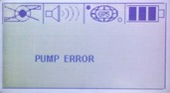
The instrument detects when the pump flow is restricted or blocked. The pump stops, the LEDs light up, the icon of the pump shows a cross and you will see the message "PUMP ERROR" is displayed on the screen.
If this error occurs, turn off the SEM5000, check the water trap filter and probe ends for potential restrictions. Once you have cleared any restrictions, restart the instrument.

If you want to turn the pump off manually, press the Selector Dial, scroll to the "ON / OFF Pump" option and press the dial again. Once pressed, the “Pump” icon will be displayed with an “X”, indicating that the pump is off.

NOTE: This menu is available only when the GPS is activated and the “Save Location” icon is shown on the display. When the pump is off, the display shows five horizontal lines “-----"

Restarting the Pump

- Press the Function button
- The “X” over the pump icon will disappear and the pump will start again

The field in the upper, left-hand corner of the screen can display two different icons:
When the GPS is off, the “Pump” icon is displayed.
When the GPS is on, the “Save Location” icon is displayed.

Note: For further information please contact Technical Support at QED at (800) 968-2026 or email landtec_support@qedenv.com.

Replacement parts

Part Number | Description
SEM-CASE | SEM5000 Carrying Case for Instrument, Telescoping Handle and Expendable Accessories
SEM-SCASE | SEM5000 Soft Carrying Case, (fanny-pack style), for Instrument only
SEM-STRAP | SEM5000 Two-Point Carrying Strap
SEM-PROBE | SEM5000 Telescoping Probe Handle with windscreen. Extends to 4' 3"
SEM-SP | SEM5000 Windscreen for Telescoping Probe
SEM-BATT | SEM5000 Battery Pack
SEM-BC | SEM5000 Battery Charger with USB Download Cable
SEM-CBC | SEM5000 12V Car Charger for Battery
SEM-QC | SEM5000 On-Demand Test Gas Regulator. Male Thread, for use with gas cylinders with C10 fitting. 0.6L/min flow rate
SEM-TUBE | SEM5000 Tubing for Probe Handle. Priced Per Foot.
SEM-WFK10 | SEM5000 Water Trap Filter Kit. Includes: 10 Hydrophobic Filters, 25mm PTFE 45um. For use in Removable Filter Holder
SEM-DFKB | SEM5000 Dust Filter Kit for extendable sample probe. Includes: 10 Bronze Dust Filters for Insertion in end of Sample Probe
SEM-DFKC | SEM5000 Dust Filter Kit for extendable sample probe. Includes: 25 Cellulose Dust Filters for insertion in end of sample probe
SEM-HOLD | SEM5000 Removable Filter Holder for Hydrophobic Filter
CGCH4-500 | Calibration gas for SEM. CH4 500ppm / Balance Air, 105L bottle
CGAIR-0 | Calibration gas for SEM. Air - Ultra Zero Grade, 105L bottle

SEM5000 warranty
This instrument is guaranteed, to the original end user purchaser, against defect in materials and workmanship for a period of 3 years from the date of the shipment to the user.
During this period QED will repair or replace defective parts on an exchange basis.
The decision to repair or replace will be determined by QED.
To maintain this warranty, the purchaser must perform maintenance and calibration as prescribed in the operating manual.
Normal wear and tear, and parts damaged by abuse, misuse, negligence or accidents are specifically excluded from the warranty.

Note: For further information please contact Technical Support at QED at (800) 968-2026 or email landtec_support@qedenv.com.

appendix a – safe use of the instrument
The information contained in these safety instructions must be followed in addition to the warnings in the user manual supplied to the customer.

Laser Radiation
The SEM5000 contains an invisible laser source. The instrument is classified Class 1 according European standards.
Do not open the device

Other Precautions for Usage
The charging of the batteries must be performed in a safe place with the appropriate external adapter.
The instrument is dedicated to measurements in ambient air or can accept gas mixture containing non-corrosive chemical products. In case of the presence of gas mixture except that hydrocarbon and neutral gases, contact QED to verify the compatibility with the device.

Testing and Maintenance
The checks and maintenance of certified equipment should be performed according to the criteria of the standard EN60079-17.

Repair
In the event of malfunction or damage is recommended to send the equipment to QED for repair.
Note: For further information please contact Technical Support at QED at (800) 968-2026 or email landtec_support@qedenv.com.

appendix b – bluetooth module compliance
The Bluetooth module has a QDID registered with the Bluetooth SIG :
QDID: B014867

United States
The device contains Transmitter Module FCC ID: T9J-RN42. This device complies with Part 15 of the FCC Rules.
Operation is subject to the following two conditions: (1) this device may not cause harmful interference, and (2) this device must accept any interference
received, including interference that may cause undesired operation.
This equipment has been tested and found to comply with the limits for a Class B digital device, pursuant to part 15 of the FCC Rules. These limits are designed to provide reasonable protection against harmful interference in a residential installation. This equipment generates, uses and can radiate radio frequency energy, and if not installed and used in accordance with the instructions, may cause harmful interference to radio communications. However, there is no guarantee that interference will not occur in a particular installation. If this equipment does cause harmful interference to radio or television reception, which can be determined by turning the equipment off and on, the user is encouraged to try to correct the interference by one or more of the following measures:
• Reorient or relocate the receiving antenna.
• Increase the separation between the equipment and receiver.
• Connect the equipment into an outlet on a circuit different from that to which the receiver is connected.
• Consult the dealer or an experienced radio/TV technician for help.

Canada
The device contains transmitter module IC: 6514A-RN42.
This device complies with Industry Canada license exempt RSS standard(s). Operation is subject to the following two conditions: (1) this device may not cause interference, and (2) this device must accept any interference, including interference that may cause undesired operation of the device.
Le présent appareil est conforme aux CNR d'Industrie Canada applicables aux appareils radio exempts de licence. L'exploitation est autorisée aux deux conditions suivantes: (1) l'appareil ne doit pas produire de brouillage, et (2) l'utilisateur de l'appareil doit accepter tout brouillage radioélectrique subi, même si le brouillage est susceptible d'en compromettre le fonctionnement.
Under Industry Canada regulations, this radio transmitter may only operate using an antenna of a type and maximum (or lesser) gain approved for the transmitter by Industry Canada. To reduce potential radio interference to other users, the antenna type and its gain should be so chosen that the equivalent isotropically radiated power (e.i.r.p.) is not more than that necessary for successful communication.
Conformément à la réglementation d'Industrie Canada, le présent émetteur radio peut fonctionner avec une antenne d'un type et d'un gain maximal (ou inférieur) approuvé pour l'émetteur par Industrie Canada. Dans le but de réduire les risques de brouillage radioélectrique à l'intention des autres utilisateurs, il faut choisir le type d'antenne et son gain de sorte que la puissance isotrope rayonnée équivalente (p.i.r.e.) ne dépasse pas l'intensité nécessaire à l'établissement d'une communication satisfaisante.

Europe
The Bluetooth module has been tested to R&TTE Directive 1999/5/EC Essential Requirements for Health and Safety (Article (3.1(a)), Electromagnetic Compatibility (EMC) (Article 3.1(b)), and Radio (Article 3.2) and are summarized below :
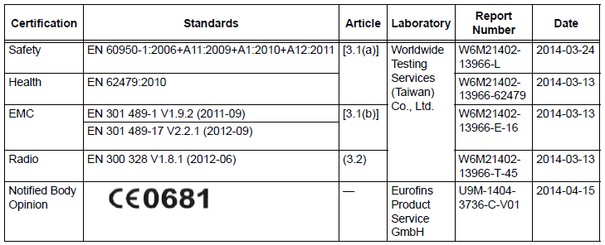

appendix C – EU Declaration of Conformity
QED Environmental Systems, Inc. declares that the product, SEM5000 Atex, is in conformity with the provisions of the following EU directives and that the standards and/or technical specifications referenced below have been applied:

-With the annex II of the 2014/34/ EU directive from 26 April 2016
- With the EN 60079-0 : 2012 + A11 :2013 - Explosive atmospheres – Part 0: Equipment – General requirements
- With the EN 60079-11:2012 - Explosive atmospheres - Part 11. Equipment protection by intrinsic safety « i »
- With the EN 60079-28:2015 - Explosive atmospheres - Part 28. Protection of equipment and transmission systems using optical radiation.
- With the 2014/53/UE Directive RED (Radio Equipment Directive) of 12th August 2016: Electromagnetic compatibility ETSI EN 301 489-1; ETSI EN 301 489-17 ; ETSI EN 301 489-19 ; EN 61326-1 (2012) ; Radio FCC 15.107/109 + ICES 003
- Protection level of the envelop: Degrees of protection provided by enclosures EN 60529 Oct 1992
- Safety of laser products: EN 60825-1:2014 + A1 (IEC)
- Certificate of calibration: according ISO/IEC 17025
- Transport of Lithium ion rechargeable battery; Battery pack non restricted for transport according to the UN3480 & UN3481 - Recommendations on the transport of dangerous goods
- With the type of apparatus that have been examined and fully approved by the INERIS notified body, rue J. Taffanel, 60550 Verneuil en Halatte (France), organization registered under the number 0080 and for which INERIS has issued a EU-Type examination certificate under the number: INERIS 18 ATEX 0029X.

The manufacturing plant in Bolzano has been registered under the number
N° TPS 17 ATEX Q 53690 008 by the TUV SUD Zertifizierstelle München, notified body registered under the number 0123.

This declaration is exclusively issued under the responsibility of the manufacturer or, where appropriate, by the authorized representative.

